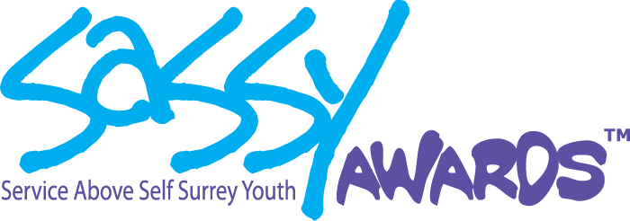

Dear Friend,

The SASSY Awards (Service Above Self Surrey Youth) is Rotary’s way to celebrate and honour the fantastic youth who live, work, volunteer and learn in Surrey and White Rock.

Recognizing and engaging exceptional youth in our community honours our core

Rotarian values of Service, Fellowship, Diversity, Integrity, and Leadership. We are also investing in our future leaders.

The 15th Annual SASSY Awards will take place on November 29, 2025. We will award 24 cash bursaries as well as donations to the recipient’s charity of choice for a total over $19.000.

Please note that SASSY is not a fundraising event - it raises awareness and is a way of engaging our diverse community - from youth who live, work, volunteer and learn in Surrey and White Rock while serving and volunteering countless hours - to charities that provide important community services for our friends, neighbours and loved ones. Every penny donated to Friends of SASSY goes into our Awards celebration and towards youth programs that continue to nurture young people and the concept of service above self, which is the backbone of what Rotary stands for.

Please consider helping us celebrate fantastic youth in our community by being a “Friend of SASSY”. You can e-transfer to semiahmoorotary.treasurer@gmail.com. PLEASE ensure you note in the comments section that this contribution is for Friends of SASSY. We gratefully welcome any and all donations, no matter the amount.

You could also mail or drop off a cheque at my store. It is Courtesy Cleaners, located in Windsor Square, 139-1959-152 Street, Surrey, BC V4A 9E3.  Please make out the cheque to Rotary Club of Semiahmoo.

Lastly, please join us at Surrey City Hall on Friday November 28th at 7:00 PM to celebrate with all of the nominees and find out who the award recipients and finalists are. Tickets are free and we will send out the invitation link closer to the date.

Thank you so very much,

Charlotte Morton

Friends of SASSY

Rotary Club of Semiahmoo

Charmort1111@gmail.com